Shyra Alexandria / 2702291356

PAGE EXPLANATION

1. Home Page

The main function of the homepage is to serve as a welcoming and engaging entry point for users, providing a clear overview of what ShipDecKK offers while guiding visitors to explore further. It introduces the brand with a strong visual banner and slogan, presents three main vessel categories (yacht, cruise, cargo) for quick access based on user needs, and builds trust through customer testimonials. Additionally, it encourages action with a call-to-action banner leading to the gallery, and offers essential navigation, contact information, and social media links in the footer to ensure a complete and user-friendly browsing experience.

1. Gallery Page

The main function of the Gallery page is to visually showcase ShipDecKK’s fleet of marine vessels, allowing users to explore and compare different types of yachts, cruises, and cargo ships. It helps users get a better sense of the design, luxury, and scale of the offerings, aiding their decision-making process. This page acts as an inspiration hub, encouraging potential clients to learn more or proceed with a booking based on what they see.

1. Services Page

The main function of the Services page is to inform users about the range of maritime services offered by ShipDecKK, such as yacht charters, cruise experiences, and cargo shipping. It helps users understand what they can expect from each service, including features, benefits, and unique selling points, enabling them to choose the service that best fits their needs.

1. About Us Page

The main function of the About Us page is to introduce users to ShipDecKK’s background, mission, vision, and core values. It helps build trust by showcasing the company's identity, history, team, and commitment to providing exceptional maritime experiences, giving users a deeper understanding of who they are engaging with.

1. Subscription Page

The main function of the Subscription page is to allow users to get notification and choose their main plans offered by ShipDecKK. It provides details about the newest packages, pricing, and benefits, enabling users to subscribe to the one that best fits their needs for continued access to premium maritime experiences.

REFERENSI || ASSETS

Fonts:

1. Libre Baskerville [https://fonts.googleapis.com/css2?family=Libre+Baskerville&display=swap](https://fonts.googleapis.com/css2?family=Libre%2BBaskerville&display=swap)
2. Montserrat <https://fonts.googleapis.com/css2?family=Montserrat&display=swap>
3. Libre Bodoni [https://fonts.googleapis.com/css2?family=Libre+Bodoni&display=swap](https://fonts.googleapis.com/css2?family=Libre%2BBodoni&display=swap)
4. Poppins <https://fonts.googleapis.com/css2?family=Poppins&display=swap>

Images:

* 1. image generator - chatgpt



* 1. image generator - chatgpt



* 1. location-on - Simple Design Sistem (figma library)



* 1. inbox - Simple Design Sistem (figma library)



* 1. phone - Simple Design Sistem (figma library)



* 1. facebook - Simple Design Sistem (figma library)



* 1. instagram - Simple Design Sistem (figma library)



* 1. linkedin - Simple Design Sistem (figma library)



* 1. anchor - google material symbols (figma plugin)



* 1. settings - Simple Design Sistem (figma library)



* 1. construction - google material symbols (figma plugin)



* 1. groups_2 - google material symbols (figma plugin)



* 1. shield - google material symbols (figma plugin)



* 1. star_filled - material 3 design kit (figma library) “yellow”



* 1. star_filled - material 3 design kit (figma library) “orange”



* 1. chevrons right - Simple Design Sistem (figma library)



* 1. [https://cdn.northropandjohnson.com/uploads/cb78e590-b322-11eb-b59b-bfd1177c77f](https://cdn.northropandjohnson.com/uploads/cb78e590-b322-11eb-b59b-bfd1177c77f4-eclipse-exterior-do-not-use-outside-feature.jpg?auto=format&q=65&h=1) [4-eclipse-exterior-do-not-use-outside-feature.jpg?auto=format&q=65&h=1](https://cdn.northropandjohnson.com/uploads/cb78e590-b322-11eb-b59b-bfd1177c77f4-eclipse-exterior-do-not-use-outside-feature.jpg?auto=format&q=65&h=1) (edited)

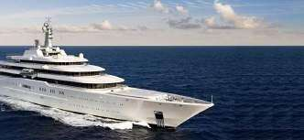

* 1. [https://encrypted-tbn0.gstatic.com/images?q=tbn:ANd9GcSzKZx_ybQhnE_vyYIjuuv](https://encrypted-tbn0.gstatic.com/images?q=tbn%3AANd9GcSzKZx_ybQhnE_vyYIjuuv545PskP4OAs64l1TlDMnm9NcnHlJmgedtC3QN7bVWR4wfTzM&usqp=CAU) [545PskP4OAs64l1TlDMnm9NcnHlJmgedtC3QN7bVWR4wfTzM&usqp=CAU](https://encrypted-tbn0.gstatic.com/images?q=tbn%3AANd9GcSzKZx_ybQhnE_vyYIjuuv545PskP4OAs64l1TlDMnm9NcnHlJmgedtC3QN7bVWR4wfTzM&usqp=CAU)

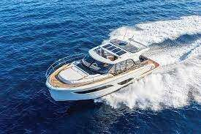

* 1. [ship_sm.jpg](https://cruise-with-points.marriott.com/images/web/354/1266/shp/ship_sm.jpg)

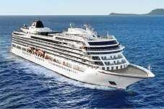

* 1. [heavy4.jpg](https://www.wartsila.com/images/default-source/encyclopedia/heavy4.jpg?sfvrsn=3eb1d145_4)

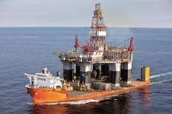

* 1. [https://www.talamare.com/medias/2885-collection-renting-a-yacht-french-riviera-for-](https://www.talamare.com/medias/2885-collection-renting-a-yacht-french-riviera-for-over-12-people.jpg) [over-12-people.jpg](https://www.talamare.com/medias/2885-collection-renting-a-yacht-french-riviera-for-over-12-people.jpg)



* 1. [https://media.istockphoto.com/id/543659548/photo/wide-angle-shot-of-front-of-the-y](https://media.istockphoto.com/id/543659548/photo/wide-angle-shot-of-front-of-the-yacht.jpg?s=612x612&w=0&k=20&c=HMVPXeqYW53FmkBNgyOfskjolurg3QysFWg8v7oRqxw%3D) [acht.jpg?s=612x612&w=0&k=20&c=HMVPXeqYW53FmkBNgyOfskjolurg3QysF](https://media.istockphoto.com/id/543659548/photo/wide-angle-shot-of-front-of-the-yacht.jpg?s=612x612&w=0&k=20&c=HMVPXeqYW53FmkBNgyOfskjolurg3QysFWg8v7oRqxw%3D) [Wg8v7oRqxw=](https://media.istockphoto.com/id/543659548/photo/wide-angle-shot-of-front-of-the-yacht.jpg?s=612x612&w=0&k=20&c=HMVPXeqYW53FmkBNgyOfskjolurg3QysFWg8v7oRqxw%3D)

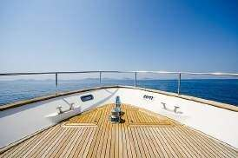

* 1. [flybridge-yacht-2024-prestige-520-power-.jpg](https://images.ctfassets.net/s4mjfxiuxdwu/6z15RgJAJskSWR5707auJ6/abecd51cb312c870686ecd643a40bd45/flybridge-yacht-2024-prestige-520-power-.jpg)

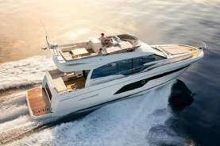

* 1. [mega-yacht-guide-206-69-delta-motor-yacht-2025.jpg](https://yatcowpmedialibrary.nyc3.cdn.digitaloceanspaces.com/wp-content/uploads/2023/03/mega-yacht-guide-206-69-delta-motor-yacht-2025.jpg)

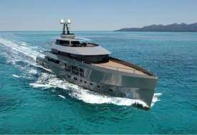

* 1. [aerial+photography+yacht+drone+photography38.jpg](https://images.squarespace-cdn.com/content/v1/63f8c51cfb450820110c87dc/1731009716256-BT637H887749VPAX6TQR/aerial%2Bphotography%2Byacht%2Bdrone%2Bphotography38.jpg)

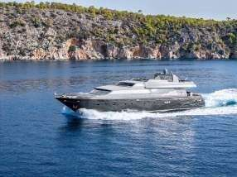

* 1. [fotografo-barche-punta-ala.jpg](https://www.gabrielesotgiu.com/wp-content/uploads/2023/11/fotografo-barche-punta-ala.jpg)

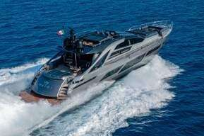

* 1. [2P7A8816-2-1-scaled.jpg](https://blueiprod.com/wp-content/uploads/2021/03/2P7A8816-2-1-scaled.jpg)

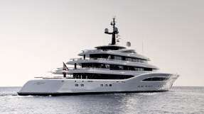

* 1. [https://yachtway.com/_next/image/?url=%2F_next%2Fstatic%2Fmedia%2Fvanquish-](https://yachtway.com/_next/image/?url=%2F_next%2Fstatic%2Fmedia%2Fvanquish-preview.fd3a2f88.png&w=2048&q=75) [preview.fd3a2f88.png&w=2048&q=75](https://yachtway.com/_next/image/?url=%2F_next%2Fstatic%2Fmedia%2Fvanquish-preview.fd3a2f88.png&w=2048&q=75)

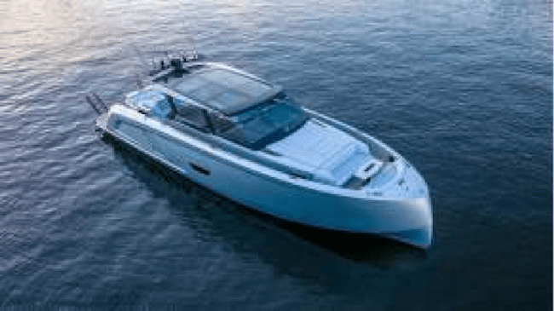

* 1. [fotografo-yacht-porto-cervo.jpg](https://www.gabrielesotgiu.com/wp-content/uploads/2023/11/fotografo-yacht-porto-cervo.jpg)

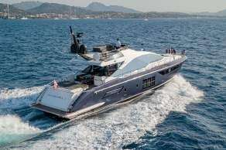

* 1. [82_Pershing_SIPSEY_AERIALS17.jpg](https://bonomotion.com/wp-content/uploads/2020/photos/82_Pershing_SIPSEY_AERIALS17.jpg)

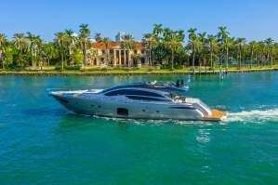

* 1. [luxury-big-yacht-stay-sea-around-island-background-sky_8353-6005.jpg](https://img.freepik.com/free-photo/luxury-big-yacht-stay-sea-around-island-background-sky_8353-6005.jpg?semt=ais_hybrid&w=740)

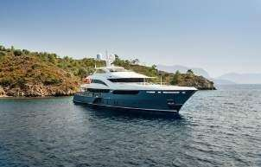

* 1. [Collection_SSC_banner.jpg](https://www.tauck.com/-/media/Tauck/Collection/Hero-Images/Collection_SSC_banner.jpg)

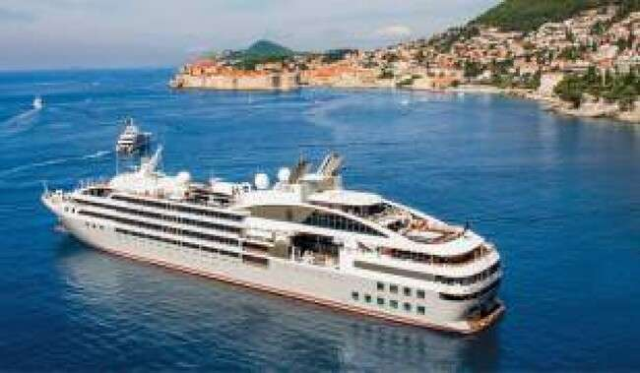

* 1. [cruise_19.jpg](https://adambruzzone.com/images/portfolio/cruise_lines/cruise_19.jpg)

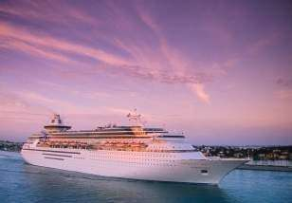

* 1. [cruise_ship.jpg](https://www.robotsforroboticists.com/wp-content/uploads/2018/01/cruise_ship.jpg)

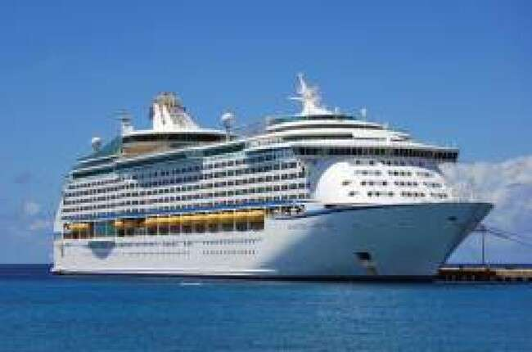

* 1. [1530649046_MA18-AerialsFL069.jpg.webp](https://www.royalcaribbeanblog.com/sites/default/files/styles/wide_1200_/public/fb/1530649046_MA18-AerialsFL069.jpg.webp?itok=mKkuondX)

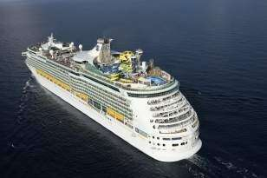

* 1. [O_sh01_fr1420_x2_v3-Bow-v2-2x1.jpg](https://cdn1.parksmedia.wdprapps.disney.com/resize/mwImage/1/870/420/75/vision-dam/digital/parks-platform/parks-global-assets/disney-cruise-line/ships/destiny/overview/O_sh01_fr1420_x2_v3-Bow-v2-2x1.jpg?2024-07-25T18%3A09%3A00%2B00%3A00)

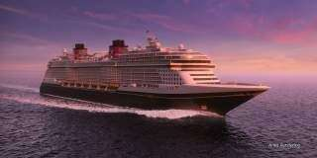

* 1. [T1111CELEBRITYEXCEL_C.jpg](https://ik.imgkit.net/3vlqs5axxjf/TW/uploadedImages/Art/2024/1111/T1111CELEBRITYEXCEL_C.jpg?n=7061&tr=w-1200%2Cfo-auto)

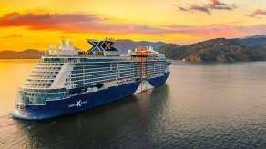

* 1. [photo-1632517306067-b54ab4d1f98d](https://images.unsplash.com/photo-1632517306067-b54ab4d1f98d?fm=jpg&q=60&w=3000&ixlib=rb-4.1.0&ixid=M3wxMjA3fDB8MHxzZWFyY2h8OHx8Y2FyZ28lMjBzaGlwfGVufDB8fDB8fHww)

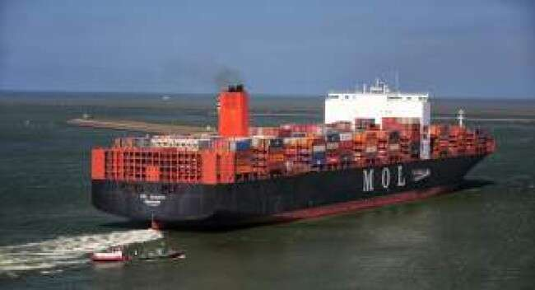

* 1. [2560px-Ursula_Essberger_2018.jpg](https://upload.wikimedia.org/wikipedia/commons/thumb/c/cd/Ursula_Essberger_2018.jpg/2560px-Ursula_Essberger_2018.jpg)

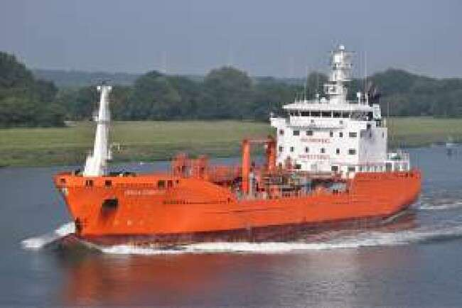

* 1. [1505992.jpg](https://www.shipspotting.com/photos/big/2/9/9/1505992.jpg?cb=0)

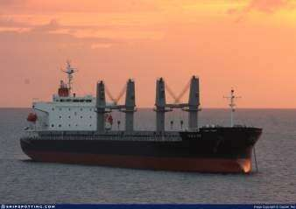

* 1. [https://static.vesselfinder.net/ship-photo/9766906-352001239-a4e7332d6857f53d8a0d](https://static.vesselfinder.net/ship-photo/9766906-352001239-a4e7332d6857f53d8a0dbf343962ffe1/1?v1) [bf343962ffe1/1?v1](https://static.vesselfinder.net/ship-photo/9766906-352001239-a4e7332d6857f53d8a0dbf343962ffe1/1?v1)

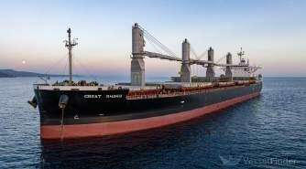

* 1. [water-sea-board-case-wallpaper-thumb.jpg](https://c4.wallpaperflare.com/wallpaper/699/16/974/water-sea-board-case-wallpaper-thumb.jpg)

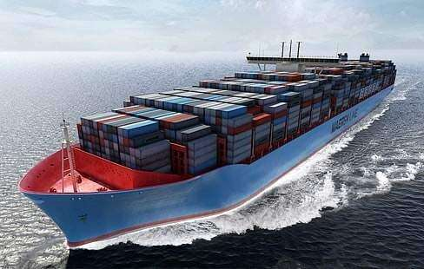

* 1. [3259150.jpg](https://www.shipspotting.com/photos/big/0/5/1/3259150.jpg?cb=0)

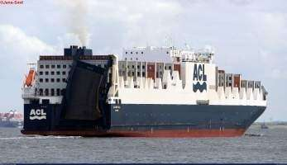

* 1. [p-90923816-Maersk.jpg](https://images.fastcompany.com/image/upload/f_webp%2Cc_fit%2Cw_1920%2Cq_auto/wp-cms/uploads/2023/07/p-90923816-Maersk.jpg)

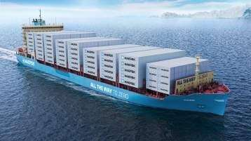

* 1. [89666afd7c1b8fba_800x800ar.jpg](https://mb.cision.com/Public/855/2993267/89666afd7c1b8fba_800x800ar.jpg)

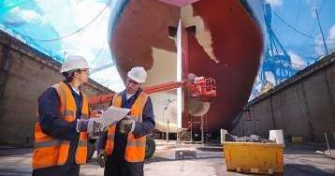

* 1. [imageresizer](https://eu-assets.simpleview-europe.com/islesofscilly/imageresizer/?image=%2Fdmsimgs%2FScillonian_people_use_1482107935.jpg&action=ProductDetailProFullWidthNew)

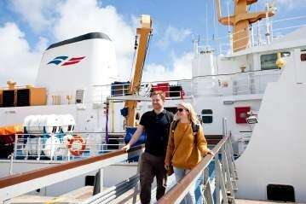

* 1. [PDXCSSQ337A 05522.1664963014.jpg](https://cdn11.bigcommerce.com/s-yzgoj/images/stencil/1280x1280/products/2640375/5604364/PDXCSSQ337A__05522.1664963014.jpg?c=2)

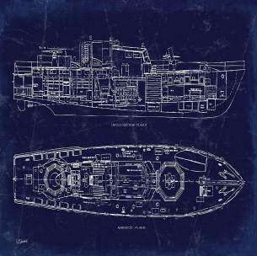

* 1. [types-of-vessel-maintenance.webp](https://wayl.eu/media/2025/02/types-of-vessel-maintenance.webp)

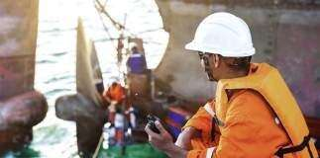

* 1. [costa-smeralda-hk-department-crew.jpg.webp](https://crew-center.com/sites/default/files/styles/blog_article_news_/public/costa-smeralda-hk-department-crew.jpg.webp?itok=Z-SzKeEg)

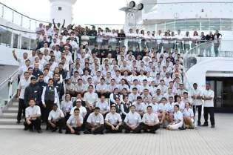

* 1. [marine-insurance.jpg](https://fbinsure.com/wp-content/uploads/2021/11/marine-insurance.jpg)

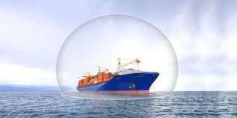

* 1. [292.png](https://knowledgeofsea.com/wp-content/uploads/2020/01/292.png)

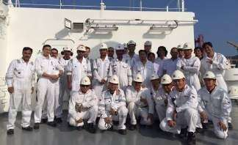

* 1. [captains1.jpg](https://www.cruisehive.com/wp-content/uploads/2023/03/captains1.jpg)

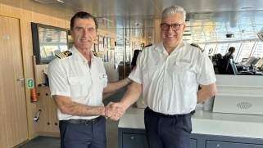

* 1. [achievement-agreement-black-and-white-business-thumbnail.jpg](https://c0.wallpaperflare.com/preview/663/94/542/achievement-agreement-black-and-white-business-thumbnail.jpg)



* 1. [close-up-of-a-girl-holding-her-hands-together-cupped-with-clean-clear-water-and-part](https://media.istockphoto.com/id/1138862363/photo/close-up-of-a-girl-holding-her-hands-together-cupped-with-clean-clear-water-and-partially.jpg?s=612x612&w=0&k=20&c=K1vbAQi6Kv69Px6GiXPjkBiXfTnH2A2eoTAZHRwnXm8%3D) [ially.jpg](https://media.istockphoto.com/id/1138862363/photo/close-up-of-a-girl-holding-her-hands-together-cupped-with-clean-clear-water-and-partially.jpg?s=612x612&w=0&k=20&c=K1vbAQi6Kv69Px6GiXPjkBiXfTnH2A2eoTAZHRwnXm8%3D)

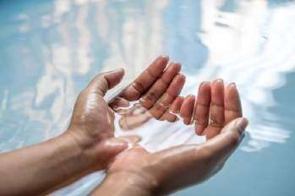

* 1. [PON_3_PON_RTD_ShipPanorama.jpg](https://imgix.swoop-antarctica.com/PON_3_PON_RTD_ShipPanorama.jpg?auto=format%2Cenhance%2Ccompress&fit=crop&crop=faces%2Cedges&w=1200&h=0&q=30)

